Software Requirements Specification
for
Vehicle Training Simulator
Version 2.0a approved
Prepared by Matt June and Cody Adams
CSC 382-01
Winter 2008
Table of Contents
Table of Contents 2
Revision History 2
1. Introduction 3
1.1 Purpose 3
1.2 Document Conventions 3
1.3 Intended Audience and Reading Suggestions 3
1.4 Product Scope 3
2. Overall Description 4
2.1 Product Perspective 4
2.2 Product Functions 6
2.3 User Classes and Characteristics 6
2.4 Operating Environment 7
2.5 Design and Implementation Constraints 7
2.6 User Documentation 7
2.7 Assumptions and Dependencies 7
3. External Interface Requirements 7
3.1 User Interfaces 7
3.2 Hardware Interfaces 7
3.3 Software Interfaces 8
3.4 Communications Interfaces 8
4. System Features 8
4.1 System Feature 1 8
4.2 System Feature 2 (and so on) 9
5. Other Nonfunctional Requirements 9
5.1 Safety Requirements 9
5.2 Security Requirements 9
Appendix A:Analysis Models 10

Name | Date | Reason For Changes | Version
Cody Adams | 04-21-08 | Final Formatting and TOC Changes for Presentation | 2.0a
Matt June | 04-18-08 | Added Appendix B and associated diagrams | 2.0
Cody Adams | 04-16-08 | Added missing sections 1.1-1.3, 2.4, 2.5, 5.1 | 1.5
Cody Adams | 04-14-08 | Added TOC and Title Page | 1.1
Matt June | 04-13-08 | Initial Release | 1.0

1. Introduction

1.1 Purpose
This document describes the software requirements for a Vehicle Training Simulator to be used for the training of ambulance and emergency rescue vehicle operators. This requirement specification outline the initial release of this project and aims to encompass the entire system, including both its software and hardware components.

1.2 Document Conventions
Throughout this document, several diagrams can be found. These are meant to be a main source of defined requirements. Rather than abstract individual diagrams, their entirety has been inserted with a brief interpretation of the specific requirements contain therein. When considering requirements, each statement should be regarded with its own priority, explicit of any higher-level requirements. This convention is as a result of the unique nature of hardware implemented in the system.

1.3 Intended Audience and Reading Suggestions
This SRS is designed for all involved parties, including developers, project managers, marketing staff, users, testers, and documentation writers. This document is intended to serve as a complete guide to everything involved in the system. This document is designed with all readers in mind and is meant to be read in the order it is presented so as to gain a full conceptual understanding.

1.4 Scope

The system will consist of the software and a mechanical device that the driver will sit in. The mechanical device will contain the interface that the driver will use to control the ambulance and a viewing screen. The device will need to be able to realistically mimic the movements of an ambulance under various road conditions and in different situations. In order to do this the software will need to be able to perform large amounts of physics calculations. The system would sync up with a database that would keep track of the statistics of the driver and his performance that could be analyzed later and could show improvements over a period of time. The user interface of the machine could be basically a stripped down ambulance. Parts of the ambulance that need to be manipulated (such as the wheel, gas, brake and clutch pedals, shifter, wipers/lights etc) would now be set up as input devices ready to read the users actions and send the information to be handled by a main physics engine. These same input devices would also need to be output devices to a degree, where pedals would need to lock up and resist in certain conditions, and the wheel would pull toward centering the tires when the ambulance was accelerating. A visual display replacing the mirrors and windows in the car would be output only devices, and the same signal sent to them could also be sent to a monitor outside the simulator so a third party, such as the instructor, could monitor the simulation.

2. Overall Description
2.1 Product Perspective
The vehicle simulator is a new self contained product. The system that this document defines is the complete vehicle simulator system.
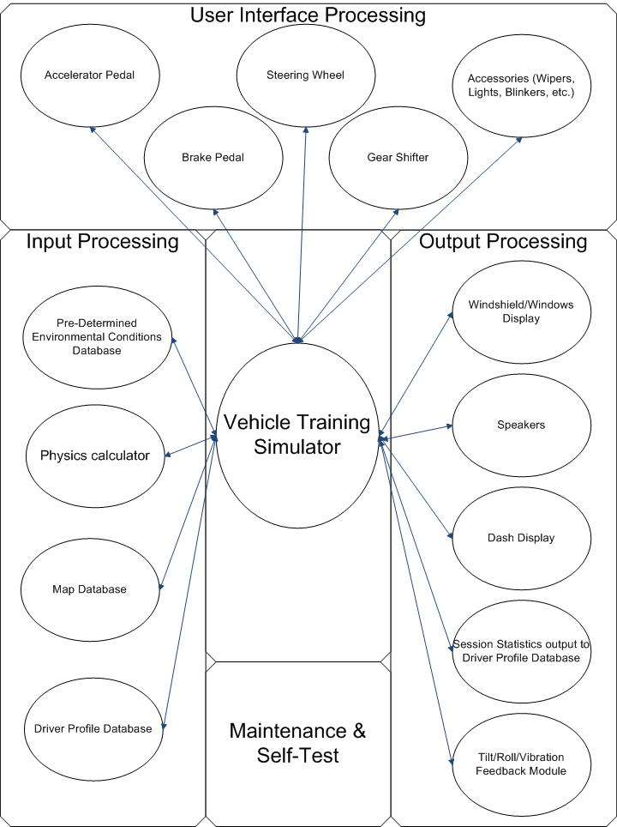

2.2 Product Functions
The vehicle simulator will need to be able to perform the following functions
- Using a feedback module, simulate with reasonable accuracy the movements that a person would feel if they were really driving an ambulance
- Provide an external viewing screen so that instructors can view the simulation
- Record session statistics so that instructors can review them when evaluating the drivers performance
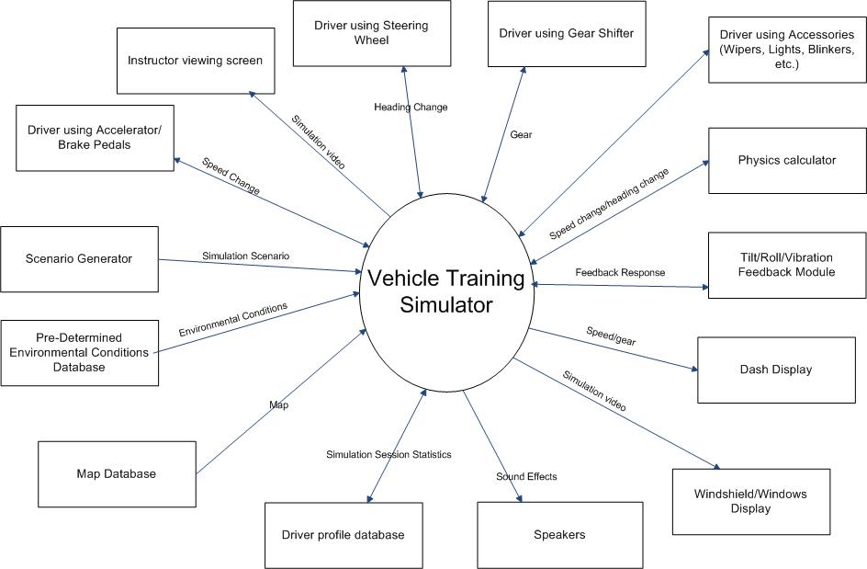

2.3 User Classes and Characteristics

There will be two types of users for the vehicle simulator, the drivers in training and the instructors who are training them.
The drivers in training will only be running the simulation, they will not be allowed to access the setup screen. They will be interacting with the accelerator, brakes, gear shifter, and the interior displays.
The instructors will be in charge of actually setting up the simulation. They will be able to access the map and environmental conditions databases in order to setup the simulation. They will also access the driver profile database to select the driver that will be running the simulation so that his or her session statistics can be stored and to review the drivers statistics. An external viewing screen will also be provided so that the instructors can view the simulation in progress.

2.4 Operating Environment
As the system is uniquely and solely designed for the purposes outlined here, the operation environment is predetermined and explicitly chosen for its qualities that are ideal to the purpose of the system. This system is independent of any other hardware or software and requires no additional specifications. Any modification to the system is not supported by this SRS and should be accompanied by its own documentation.

2.5 Design and Implementation Constraints
Design and implantation constraints are to be determined based on pending hardware design. As this system is entirely new, many changes will occur to both the software and hardware subsystems during the fluid design process. Complete constraint specifications are dependent on subsequent prototypes, as they are available.

2.6 User Documentation
A user manual for instructors containing the procedures for setting up the system will be provided. A manual will also be provided to users to explain how to use the simulator components. In addition recorded tutorials will be provided to show instructors how to setup simulations and access the databases. Other recordings will be provided that detail safety procedures drivers and instructors should follow when using the simulator.

3. External Interface Requirements

3.1 User Interfaces
Instructors will access the system using a standard keyboard and mouse. The instructors will have screens to choose a map, environmental scenarios, and driver profiles. If a map, environmental scenario, or driver profile that the instructor chooses cannot be found they will be informed. Another screen will allow instructors to access the driver profile database and review the statistics of each session that the driver has done as well as overall average statistics for all the driver’s sessions.

Inside the simulator the driver will interact with the brakes, accelerator, steering wheel, and shifter. There will be a screen that displays the simulation. The screen will also display when the simulation starts and ends, objectives, and when the user completes or fails to complete an objective.

3.2 Hardware Interfaces

When the gear is shifted it will send the new gear to the software which will store the new gear. When the accelerator is pressed the magnitude of the press is sent to the software which will use magnitude of the press along with the current gear to calculate the vehicles acceleration. The acceleration will be sent to the physics calculator which will calculate the feedback response and send it to the feedback module.
When pressed, the brakes will send the magnitude of the press to the software which will then use that information to calculate the magnitude of deceleration. This information will then be sent to the physics calculator which will calculate the feedback response and send that information to the feedback module
The steering wheel when turned will send the magnitude and direction of the turn to the software. The software will use this information to determine the alteration in the vehicles heading. This information will then be sent to the physics calculator which will calculate the appropriate feedback responses and send them to the feedback module.

3.3 Software Interfaces

The software will need to access a maps database, environmental conditions database, and driver profile database. The software will need to be able to retrieve a list of all available maps and be able to retrieve a specific map to be used in the simulation. The software will also need to be able to access a list of possible environmental scenarios and select the one that will be used in the simulation. The software will also access a driver profile database to store session statistics for each simulation a driver completes and will need to be able to access statistics for all the drivers sessions.

3.4 Communication Interfaces

The simulation system will not be connected to a network so no communication interfaces will be needed. The 3 databases will be stored on the systems hard disk. Any updates to the system software or databases will be done by the directly accessing the system.

4. System Features

4.1 Feedback Module

4.1.1 Description and Priority
The feedback module allows the system to simulate the forces a person in a vehicle would experience under various road and environmental conditions. The module can tilt the car forward, backward, left or right, rotate the car around the z-axis, and cause vibrations in order to simulate forces.
4.1.2 Stimulus/Response sequences
The feedback module can be triggered by the following stimuli:
- The driver using the accelerator
- The driver using the brakes
- The driver using the steering wheel
- Map data, this can be from anomalies in the terrain or interaction with other objects on the road
- The environmental database, things such as ice patches or puddles of water can trigger responses
4.1.3 Functional Requirements
REQ1: There needs to be a physics calculator Present in order to determine what feedback responses are appropriate
4.2 Physics calculator
4.2.1 Description and Priority
The physics calculator will be used to calculate the feedback responses for the feedback module. It will use speed changes, heading changes, environmental data and map data to determine the appropriate feedback. This is a very important feature for the system, the feedback module cannot function without it.
4.2.2 Stimulus/Response sequences
The physics calculator is triggered by the following
- The driver using the accelerator
- The driver using the brakes
- The driver using the steering wheel
- Map data
- Terrain data
Each time one of these events occurs the physics calculator will calculate tilt, rotation, and vibration responses and send them to the feedback module.
4.2.3 Functional Requirements
REQ1: The algorithms for the physics calculator will need to be very efficient. The calculations will likely be triggered many times per second especially if the road is rough.
5. Other Nonfunctional requirements
5.1 Safety Requirements

Because the simulator will be getting moved around quite a bit by the feedback module there will be safety restraints that the driver will be required to wear while the simulation is in progress. In addition both instructors and drivers will be required to view videos that will instruct them how to use the system safely before they are allowed to operate the simulator.

5.2 Security Requirements

Because the simulator does not contain any network interfaces there is no risk of anyone hacking into the driver profile database. The organization that owns the system will be responsible for ensuring that no one can get to the simulator without authorization.

Appendix A: Analysis Models

1st level DFD
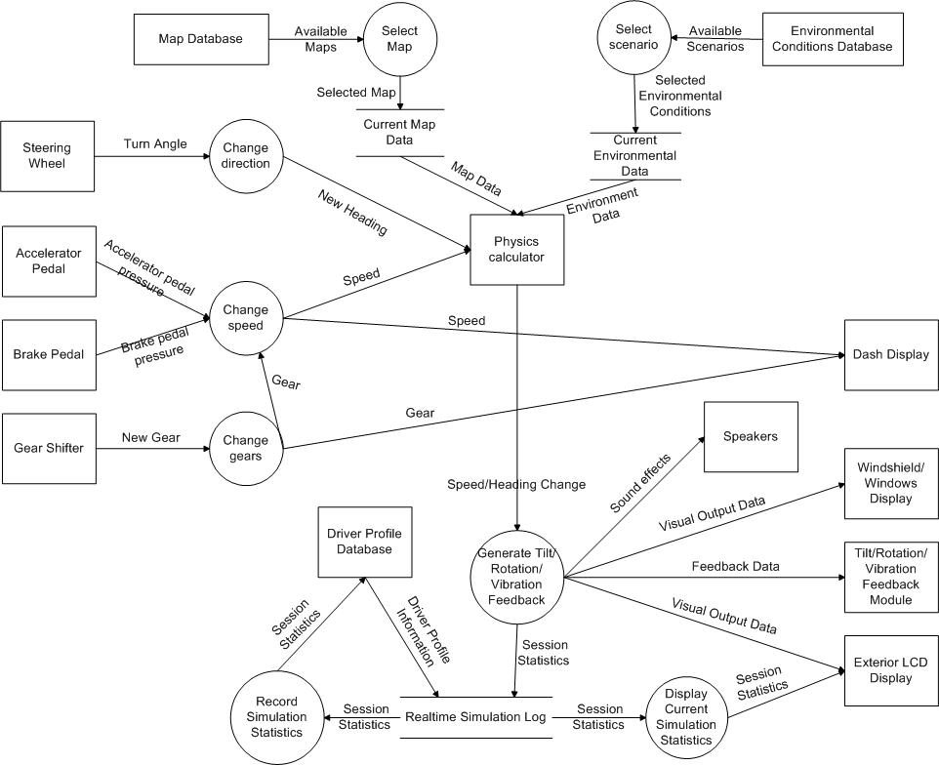

2nd level DFDs
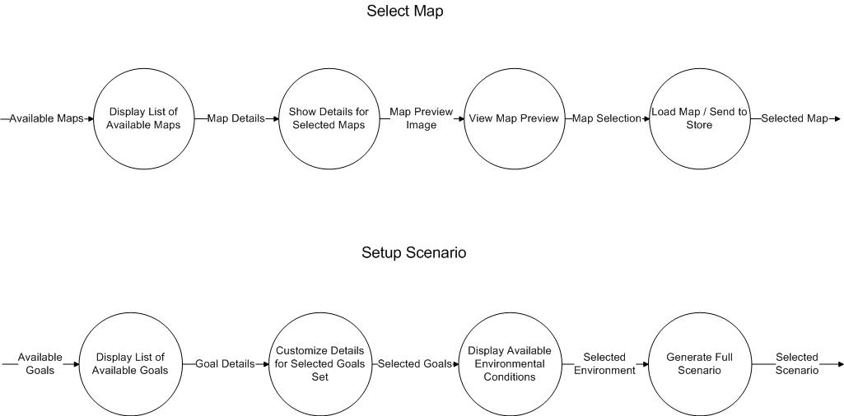

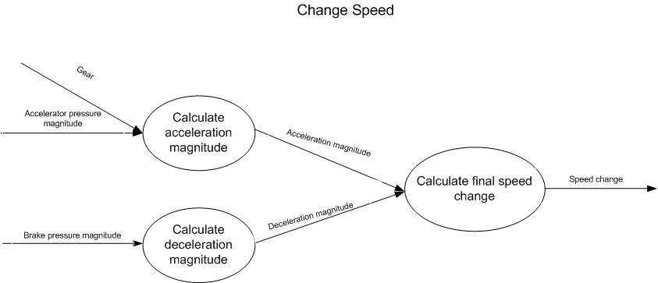
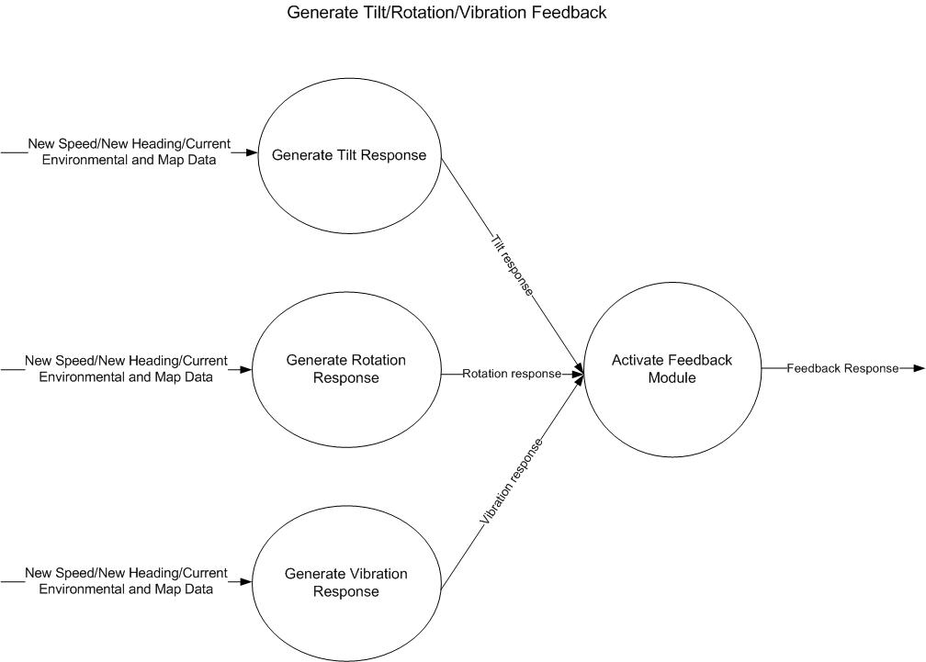

3rd Level DFDs

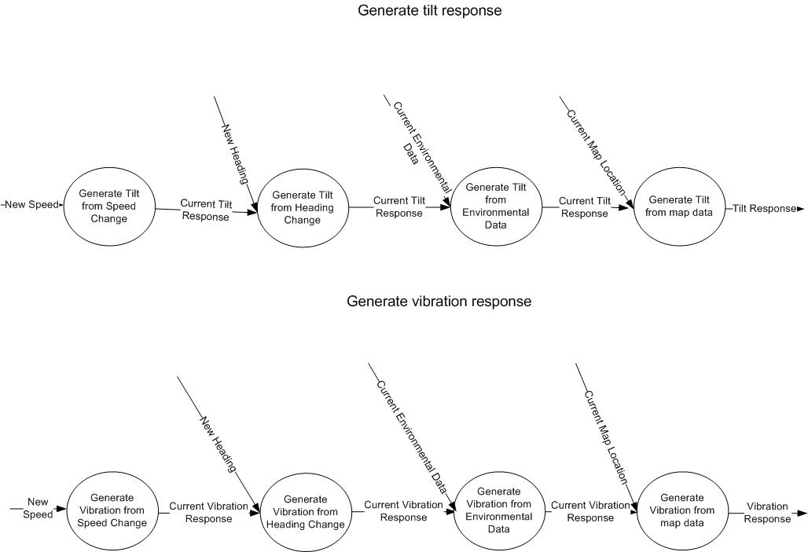

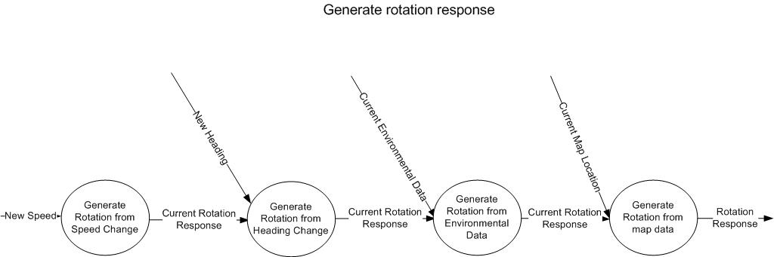
PSPECs
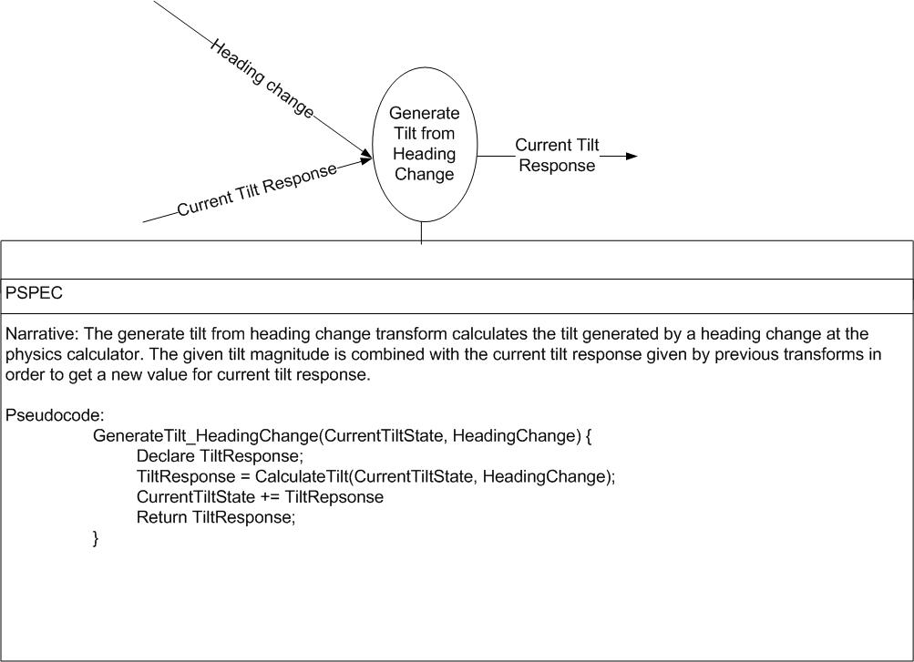
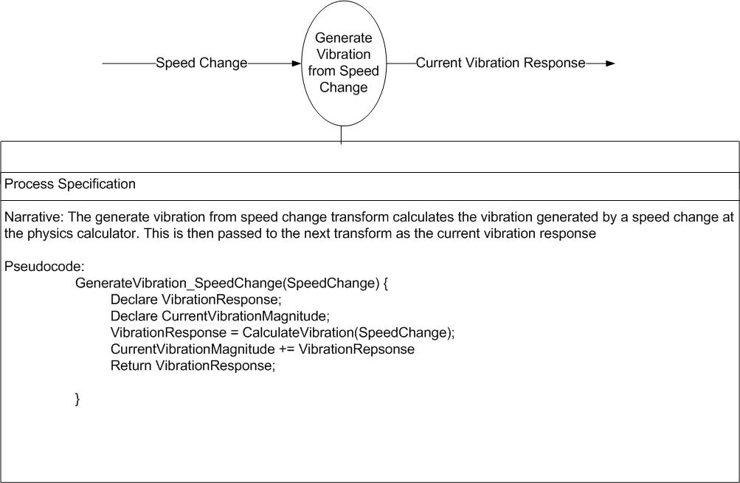

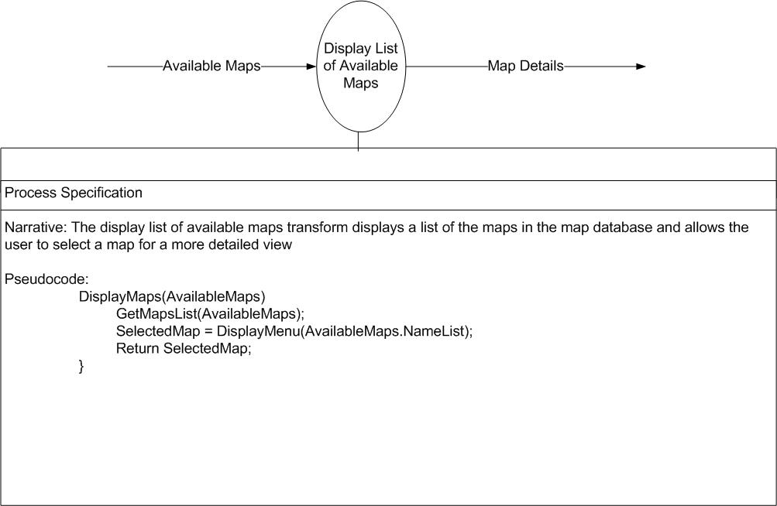
Class List:
Actor Classes
Driver
Instructor
Business Classes
Physics calculator
Feedback module
Driver profile database
Environmental conditions database
Map database
Interface Classes
Driver viewing screen
Instructor viewing screen
Instructor setup screen
Dash display
Shifter
Steering wheel
Accelerator
Brakes

CRC cards:
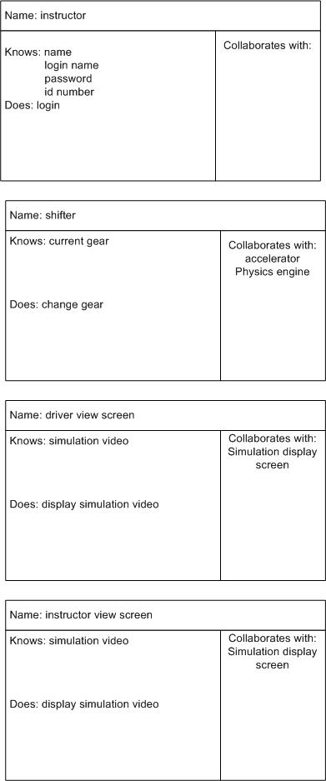
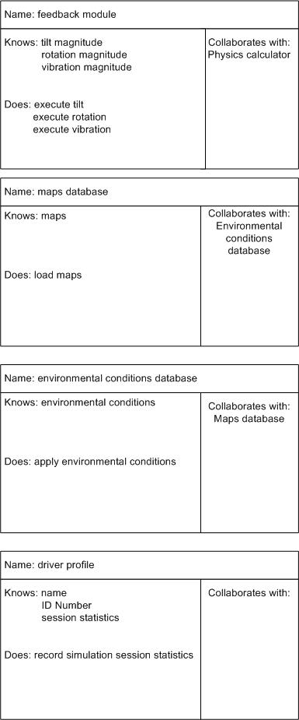
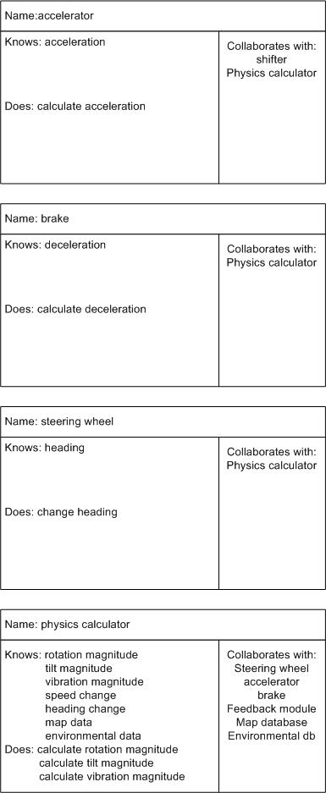

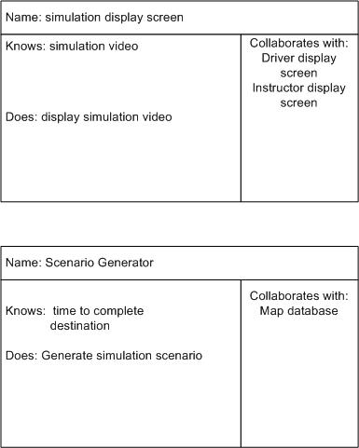

Class Relations:

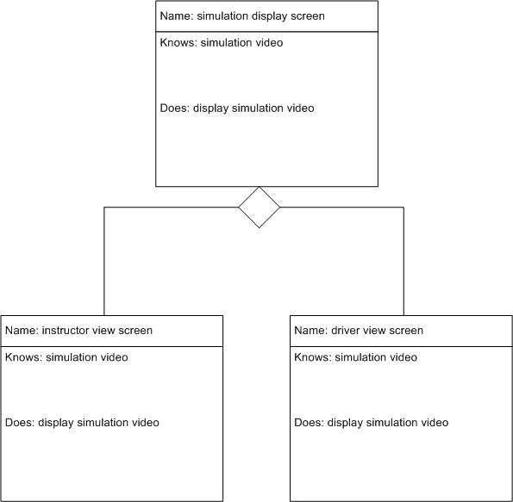

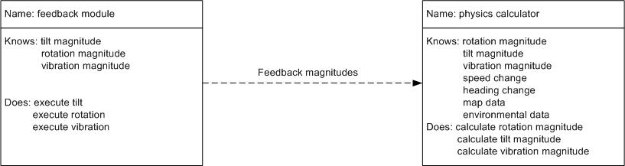
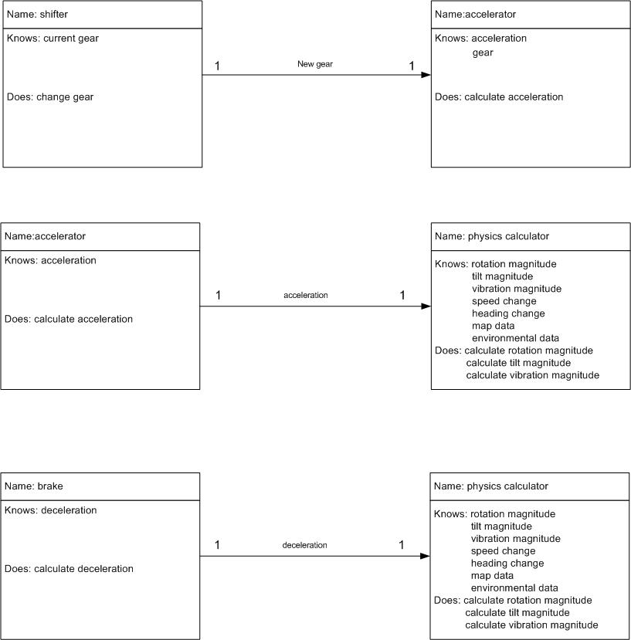
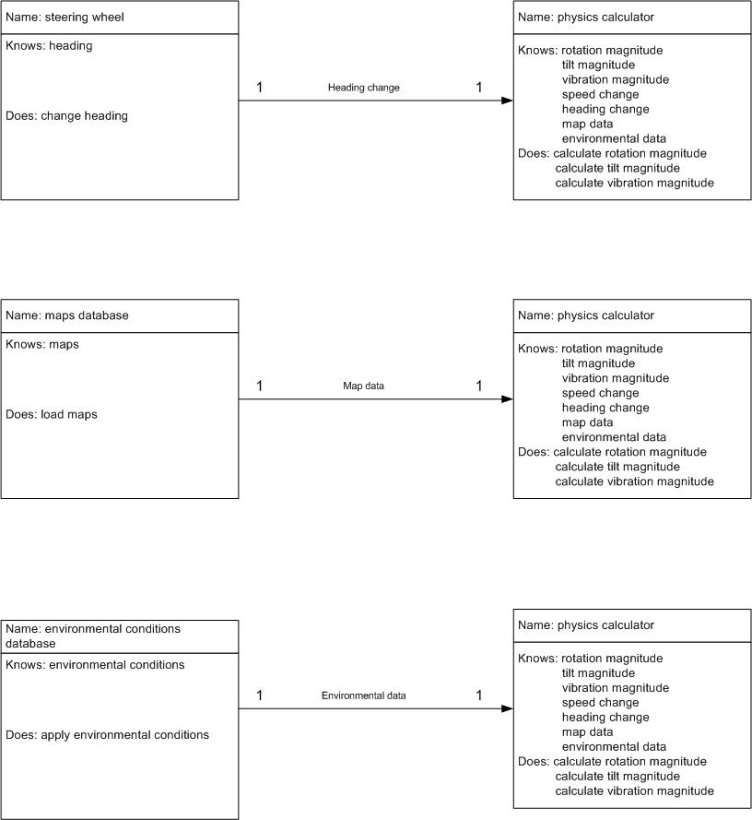
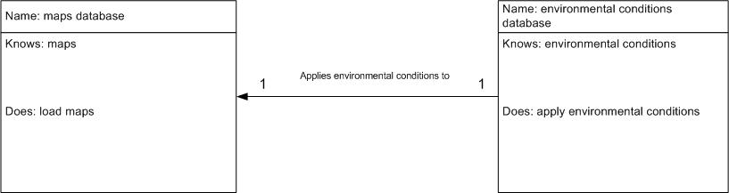

Use case diagram
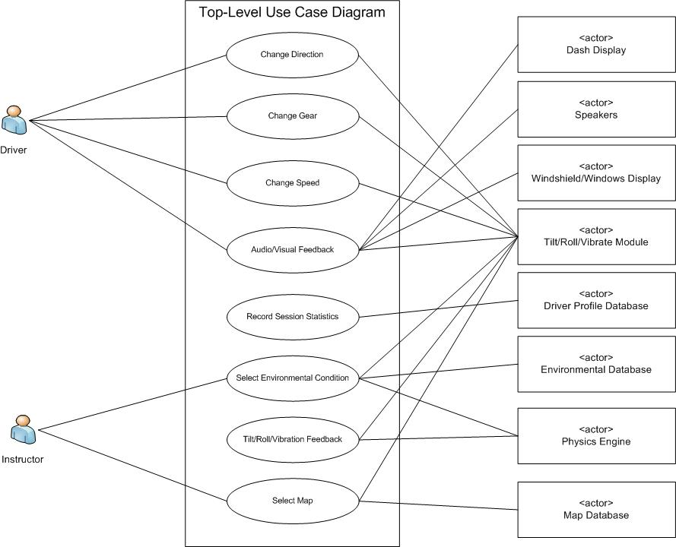

Text Use Cases
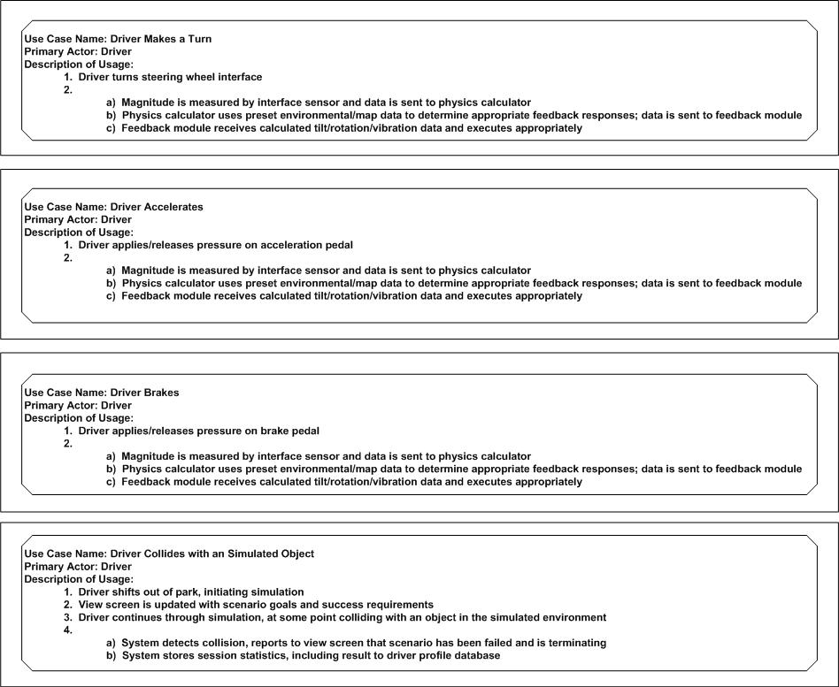

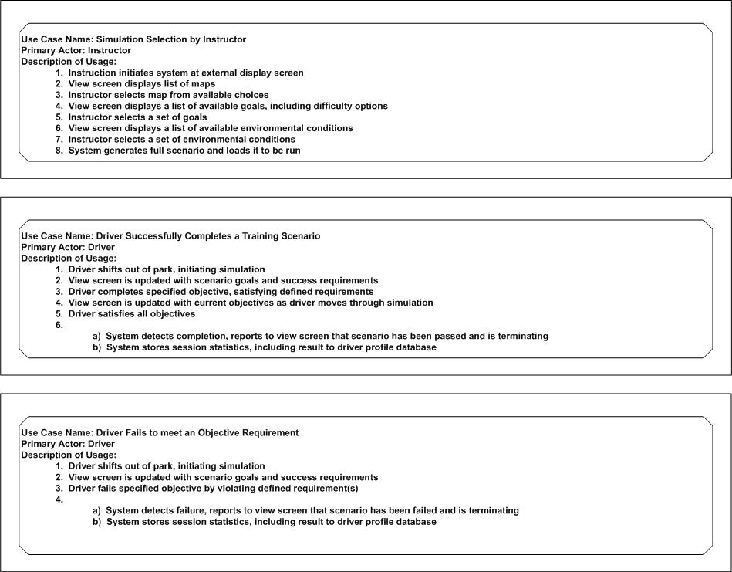

Sequence Charts
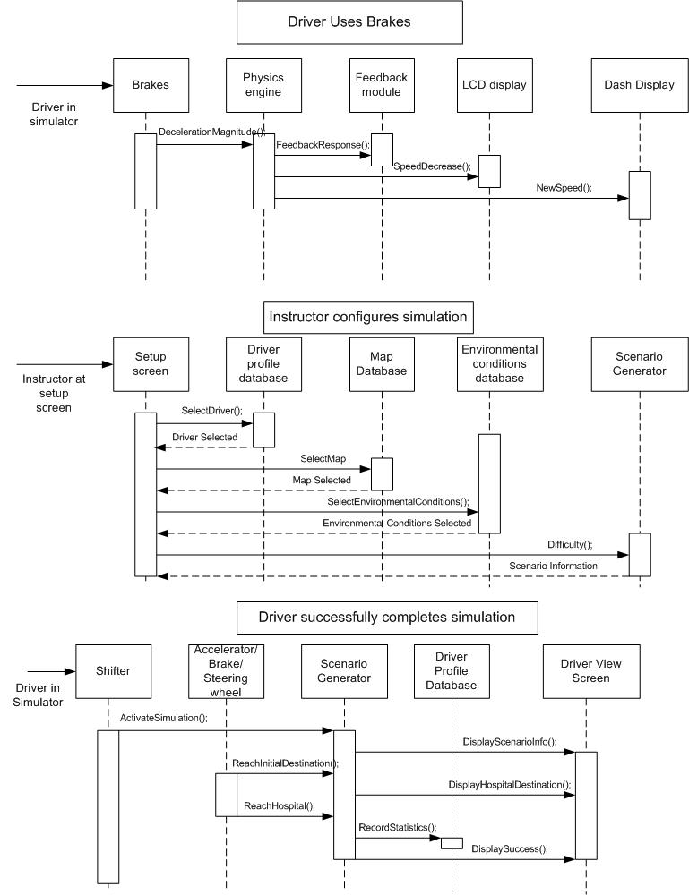
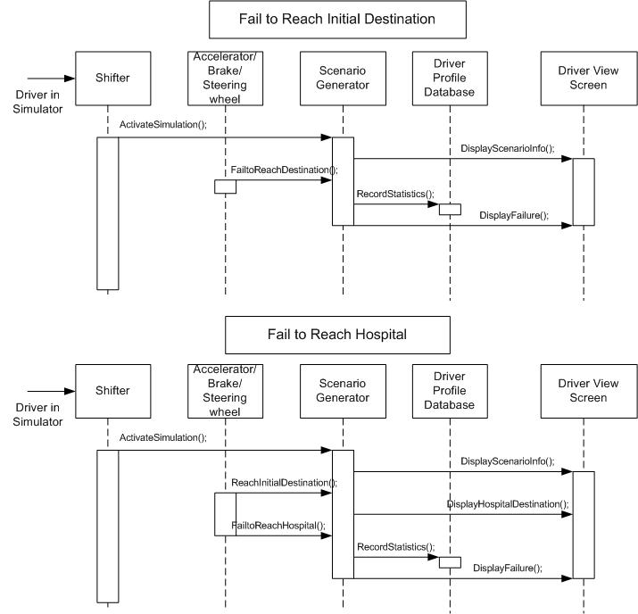

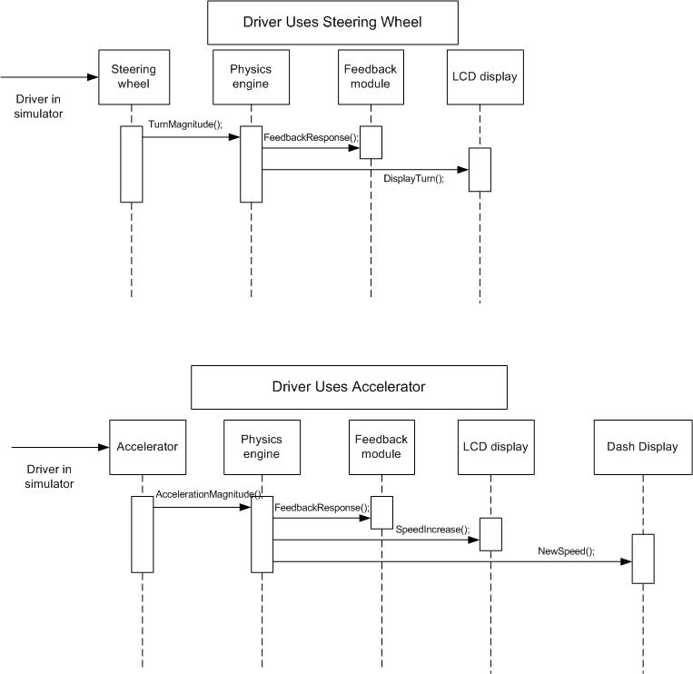

Architecture
